A Portable Readout System for
Micro-pattern Gas Detectors and Scintillation Detectors
Siyuan Ma^{1,2}[86-0551-63600408], Changqing Feng^{1,2}[86-0551-63600408], Laifu Luo^{1,2}[86-0551-63600408] and Shubin Liu^{1,2}[86-0551-63606782]
¹ State Key Laboratory of Particle Detection and Electronics, No.96, Jinzhai Road, Hefei, China
² University of Science and Technology of China, No.96, Jinzhai Road, Hefei, China
fengcq@ustc.edu.cn
Abstract. A system of readout electronics used for both Micro-pattern Gas detectors and Scintillation detectors is introduced in this paper. This system is intended as a general purpose multi-channel readout solution for a wide range of detector types and detector complexities. A 32-channel charge measurement ASIC VATA160 from IDEAS cooperation is adopted in this method. With features of high integration, low noise and large dynamic range, this system handles up to 128 electronic channels. With integration time of 1.8 us, each channel’s dynamic range is from -1 pC to +12 pC with a noise of better than 2.5 fC and nonlinearity of better than 0.5%. As a portable system, it is able to generate trigger itself or get external trigger. This system transfers data to a PC host and gets controlled by PC via only one Universal Serial bus.
Keywords: VATA160, Readout System, MPGD, Scintillation Detector
- Introduction

With the development of high energy physics (HEP), the Micro-pattern Gas Detector (MPGD) such as Micromegas [1] and Gas Electron Multipliers (GEMs) [2] and scintillation detector are widely used in particle detection physics and space astrophysics [3]. In order to meet the requirement of the early stage’s test, a portable readout electronic system was implemented and verified by the authors.
This system is based on the chip of VATA160 [4], which is a large dynamic range charge measurement readout Application-Specific Integrated Circuit (ASIC) with self-trigger function designed by IDEADS (Norway). It has 32 charge sensitive channels. The ASIC is designed for scintillation detector and MPGD. This system, which can acquire 128 channels of charge inputs, has been developed and can be used to research the performance of MPGDs as well as scintillation detectors. With integration time of 1.8 us, the dynamic range is from -1 pC to +12 pC, and the noise level is better than 2.5 fC in RMS. The system is compact and portable to use. It communicates with the PC via only one USB bus. Since its total power dissipation is lower than 2.5 W, it is able to be supplied by USB bus. The system generates trigger itself or gets external trigger.
- Design of the Readout System

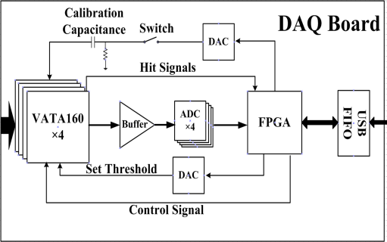
Fig. 1. Block diagram of electronic board.

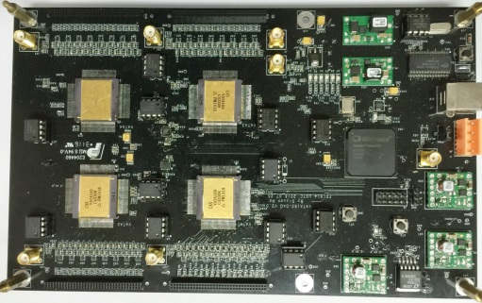
Fig. 2. Photo of the readout electronic board.

The system is mainly composed of a readout electronic board and a data-acquisition software on PC. The block diagram of electronic board is given in Fig. 1. It mainly consists of 4 VATA160 chips, 4 Analog to Digital Converters (ADC), a Field-Programmable Gate Array (FPGA), 2 Digital to Analog Converters (DAC) and a USB interface chip. Each VATA chip has a connector of 2×32, 50 mil double row pins as interface to detectors. Since the spark of MPGDs may damage the measurement channel, the Chip NUP4114 is adopted in every input channel as Electro-Static Discharge (ESD) protection. The ADC of AD7944 is used to convert analog output of ASIC into digital. A DAC is used to set threshold for trigger. The automatic calibration function has been designed on board. It is mainly composed of a DAC, an analog switch and a capacitance. To simulate the charge from detector, a controllable step voltage is generated by DAC and analog switch. Then the calibration capacitance turns the step voltage into current pulse, which is injected into ASIC’s input channel. This portable readout system has been implemented as shown in Fig. 2.
- Performance of readout system.

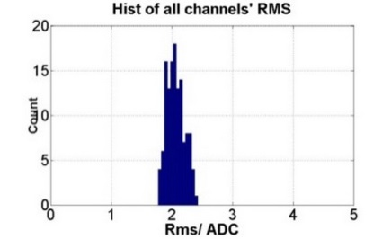
Fig. 3. RMS of all channels.
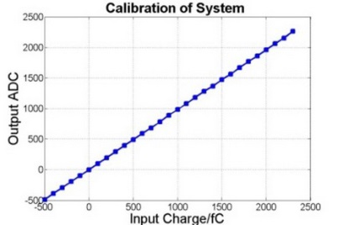
Fig. 4. Calibration of one channel.

We present the results of performance test of the readout system. The electronic noise of all 128 channels has been test and the result is shown in Fig. 3. The figure indicates that the noise of every channel is better than 2.5 Least Significant Bits (LSB), which means the equivalent input charge is 2.5 fC. Every channel of this system has been calibrated. As is shown in Fig. 4, the typical result of integral nonlinearity (INL) between -500 fC to +2.5 pC is better than 0.5%. one ADC channel stands for 1 fC. The range of -500 fC to +2.5 pC covers most of the application requirements.

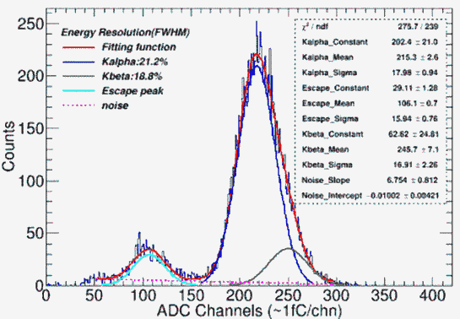
Fig. 5. The spectrum of ⁵⁵Fe
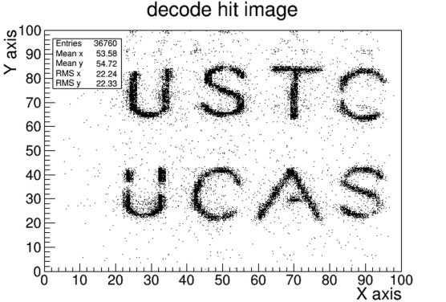
Fig. 6. The results of decoded image

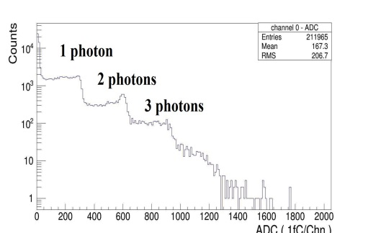
Fig. 7. Single photon peaks of SiPM
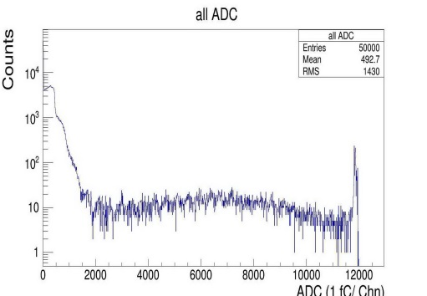
Fig. 8. Cosmic spectrum of plastic scintillator.

This system was coupled with a Micromegas detector [5] to test the energy spectrum of ⁵⁵Fe. The result is shown in Fig. 5. The all-around peak and escape peak are clearly visible, which means the readout system is capable of performing the readout of Micromegas detector.
The encoded multiplexing readout method for Thick Gas Electron Multiplier (THGEM) is a novel method which can significantly reduce the number of readout channels [6] [7]. In this part, the readout system was connected to a THGEM detector with the Two-Dimensional direct coding readout of 100×100 anode bars to perform imaging test. There was a copper plate with letter slits between the detector and X-ray generator. After collecting the X-ray signal which entered the detector through the slits of the copper plate, the two-dimensional imaging was obtained by decoding the hit position of the incident signal. As is shown in Fig. 6, the letter gap is clearly visible when the threshold is set to triple the noise.
A Silicon Photomultiplier (SiPM) was used to couple with plastic scintillation detectors to collect photons. This readout system was connected with the SiPM (S13360-1350PE of Hamamatsu) [8] at the voltage of 56 V to test the photoelectron peaks. As is shown in Fig. 7, the result shows that the difference between 1 photon and 2 photons’ peak is 280 fC, which means the gain of single photon is 1.75× 10⁶. The gain is consistent with the datasheet and this means the readout system works well with SiPM. Fig. 8 shows the cosmic spectrum of the detector is able to see, despite having a lot of single photon noise and having some accumulation over 12 pC.
- Conclusion.
A portable readout electronic system for MPGDs and Scintillation detectors is presented in this paper. It shows the readout systems has features of low noise (less than 2.5 fC), high dynamic range (-1 ~ +12 pC), low power dissipation (less than 2.5 W) and high integration (128 channels). This system is portable to use with only one USB bus for its supply, commands and data transmission. This system operates with different types of MPGDs and Scintillation detectors.
- Acknowledgements
This work was supported by National Natural Science Foundation of China (Grant No. 11222552 and 11635007) and National Key R&D Program of China (Grant No. 2016YFA0400303).

References
- Giomataris Y, et al.: MICROMEGAS: a high-granularity position-sensitive gaseous detector for high particle-flux environments[J]. Nuclear Instruments and Methods in Physics Research Section A: Accelerators, Spectrometers, Detectors and Associated Equipment, 376(1), 29-35 (1996).
- Sauli F: GEM: A new concept for electron amplification in gas detectors[J]. Nuclear Instruments and Methods in Physics Research Section A: Accelerators, Spectrometers, Detectors and Associated Equipment, 386(2-3), 531-534 (1997).
- Jin C.: Dark Matter Particle Explorer: the first Chinese cosmic ray and hard γ-ray detector in space[J]. Chinese Journal of Space Science, 34(5), 550-557 (2014).
- IDEALS Homepage, http://ideas.no/products/ide3160-2/, last accessed 2017/6/14.
- Yunlong Z, et al.: Manufacture and performance of the thermal-bonding Micromegas prototype[J]. Journal of Instrumentation, 9(10), C10028 (2014).
- Qian L, et al.: A successful application of thinner-THGEMs[J]. Journal of Instrumentation, 8(11), C11008 (2013).
- Binxiang Q, et al.: A novel method of encoded multiplexing readout for micro-pattern gas detectors[J]. Chinese physics C, 40(5), 58-62 (2016).
- HAMAMATSU Homepage, http://www.hamamatsu.com/us/en/S13360-1350PE.html, last accessed 2017/6/14.

